**Report on the Effects of Natural Disasters on Cambodian Households’ Financial Condition**

1. **Data and key variables**
   1. **Dependent variables: Financial condition indicators for the household**

The dependent variables include the indicators for the household financial condition in Cambodia, including income, expenditure, having debt, total borrowings, borrowings from formal financial institutions, and vulnerability indicators. We find these indicators from the Cambodian socio-economic surveys (CSES). In addition to total income, we separately consider income from crop cultivation, livestock, and employment. For expenditure also, we include food and non-food expenditure, expenditure related to crop cultivation and livestock rearing separately, and total expenditure. We converted all the income and expenditure data to annual data for consistency and comparison purposes although several of them are weekly, monthly, and bi-annually.

Food expenditure, for example, originally includes the values of consumption of food, beverages, and tobacco items in Riel, during the last 7 days before the interview. These food items include those purchased in cash or imputed values for own production, wages in kind, gifts, and free collections. The non-food expenditure also includes both purchased in cash and in-kind expenditure or gifts, however, the period ranges from the last 1 month to 12 months before the interview.

Moreover, for communication, transport, medical expenses, and personal care, the data covers the last 1 month’s consumption before the interview. However, for clothing and footwear spending, the data is for the last 6 months. For the rest of non-food expenditures, including furniture, education, recreation, accommodation, purchasing vehicles, special occasions, taxes, and etc..., the values are for the last 12 months.

Having debt is a binary variable indicating whether the household has outstanding debts to other households or institutions. Total borrowings include the total amount borrowed by the household in Riel terms from other households or institutions. Further, borrowings from formal financial institutions will be constructed as a dummy (binary variable) if the household borrows from banks, non-governmental organizations (NGOs) (non-profit and profit), and microfinance institutions (MFIs).

For the purpose of simplicity in the interpretation, we take the logarithms of income, expenditure, and total borrowings in the main analysis for the effect of natural disasters on household financial condition. Table 1.1 presents the summary statistics for the logarithm of income, expenditure, and borrowing variables, and vulnerability indicators for the past 7 days and 30 days before the survey.

Vulnerability, in this context, refers to the lack of food or money to buy it. To measure the degree of vulnerability, we use the data from CSES reporting the households’ several strategies to cope with this problem. The strategies include relying on less preferred and less expensive food, borrowing food or relying on help from friends or relatives, reducing the number of meals eaten per day, and reducing the portion size of meals during the last 7 days before the interview.

Moreover, we consider more indicators for a longer time span, including whether there was ever no food to eat, sold household goods, and sold productive assets, spent savings and sold house or land during the past 30 days. We construct dummies for each strategy indicating that the household uses the strategy at least for 1 day during the last 7 days and 30 days before the interview.

|  |  |  |  |
| --- | --- | --- | --- |
| Table 1.1: Summary statistics for income, expenditure, and borrowing, and vulnerability indicators. | | | |
|  |  |  |  |
| Variable | Mean | Std. Dev. | Obs |
| *Income* |  |  |  |
| Log of total income | 16.084 | 1.217 | 27,251 |
| Log of income from employment | 16.353 | 0.815 | 19,968 |
| Log of income from crop | 14.578 | 1.213 | 16,335 |
| Log of income from livestock | 13.212 | 1.758 | 10,055 |
| *Expenditure* |  |  |  |
| Log of total expenditure | 16.767 | 0.684 | 30,851 |
| Log of food expenditure | 16.148 | 0.625 | 30,848 |
| Log of non-food expenditure | 15.689 | 0.958 | 30,851 |
| Log of crop expenditure | 13.799 | 1.142 | 16,351 |
| Log of livestock expenditure | 12.324 | 1.464 | 16,271 |
| *Borrowing* |  |  |  |
| Having debt = 1 | 0.333 | 0.471 | 30,851 |
| Log of total borrowing | 15.545 | 1.428 | 10,287 |
| Formal financial institution = 1 | 0.273 | 0.446 | 30,851 |
| *Vulnerability (past 7 days)* |  |  |  |
| Used cheap food = 1 | 0.061 | 0.240 | 30,851 |
| Borrowed food = 1 | 0.016 | 0.125 | 30,851 |
| Reduced meal number = 1 | 0.007 | 0.081 | 30,851 |
| Reduced meal size = 1 | 0.010 | 0.098 | 30,851 |
| *Vulnerability (past 30 days)* |  |  |  |
| Ever no food = 1 | 0.308 | 0.462 | 30,851 |
| Sold household goods = 1 | 0.001 | 0.038 | 30,851 |
| Sold productive assets = 1 | 0.001 | 0.033 | 30,851 |
| Spent savings = 1 | 0.011 | 0.106 | 30,851 |
| Sold house or land = 1 | 0.001 | 0.029 | 30,851 |
| *Notes*: Total income is the sum of income from employment, crop cultivation and livestock rearing. Similarly, total expenditure is the sum of food and non-food expenditure, and expenditures related to crop cultivation and livestock rearing. | | | |

* 1. **Natural disaster indicators**

For natural disasters in Cambodia, we focus on the three common disasters, including drought, flood, and storm. For this purpose, we collect these indicators from the Cambodian community database (CDB). Drought, flood, and storm indicate the number of families affected by heavy drought, flood, and storm, at the village level. For the analysis purpose, we create a single dummy for disaster considering drought, flood, and storm. Table 1.2 reports the summary statistics for the disaster indicators.

|  |  |  |  |
| --- | --- | --- | --- |
| Table 1.2: Summary statistics for disaster indicators. | | | |
|  |  |  |  |
| Variable | Mean | Std. Dev. | Obs |
|  |  |  |  |
| Flood = 1 | 0.187 | 0.390 | 30,851 |
| Drought = 1 | 0.319 | 0.466 | 30,851 |
| Storm = 1 | 0.286 | 0.452 | 30,851 |
| Any disaster = 1 | 0.523 | 0.499 | 30,851 |
| *Notes*: Flood, drought, and storm are dummies indicating if at least one household or family is affected by the respective disasters in the commune. Any disaster is a dummy representing if at least a single family is affected in a commune. | | | |
|  |  |  |  |

Storm, flooding, and drought are common disasters affecting a large number of people in Cambodia. The incidence of these disasters varies by region in Cambodia. We measure incidence by the number of persons or families affected by the disasters in each district. We classify the degree of disaster incidence into quartiles. Eastern and South-western Cambodia seems relatively safe from either of the disasters.

Figure 1.1 presents the number of persons (on the left-hand side) and families (on the right-hand side) affected by storms. The figures show that storm incidence is high among districts around north-western, central, and south-eastern Cambodia. Particularly, most districts in Banteay Meanchey, Oddar Meancheay, Battambang, Pursat, Stung Treng, Kampong Chhnang, Kampong Cham, and Kampot provinces are highly affected.

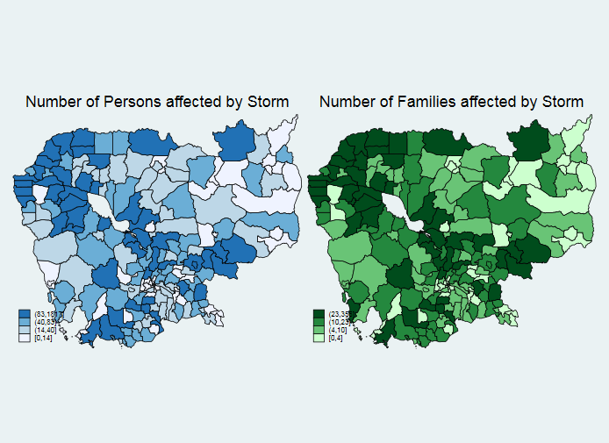

Figure 1.1: Storm Incidence Quartiles by District in Cambodia

Figure 1.2 presents the number of persons (on the left-hand side) and families (on the right-hand-side) affected by flooding. The figures show that flood affects mostly the districts in Banteay Meanchey, Battambang, Preah Vihear, Stung Treng, Kampong Thom, Kratie, Kampong Cham, and Prey Veng provinces.

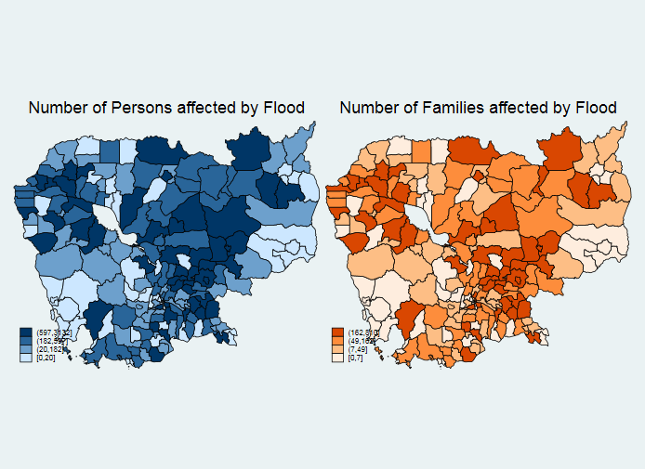

Figure 1.2: Flood Incidence Quartiles by District in Cambodia

Figure 1.3 presents the number of persons (on the left-hand side) and families (on the right-hand side) affected by drought. The figures show that drought affects mostly the north-western, central, and south-eastern parts of Cambodia. Particularly, most districts in Banteay Meanchey, Oddar Meanchey, Battambang, Siem Reap, Eastern Pursat, Kampong Thom, Kampong Speu, and Kratie provinces are highly affected.

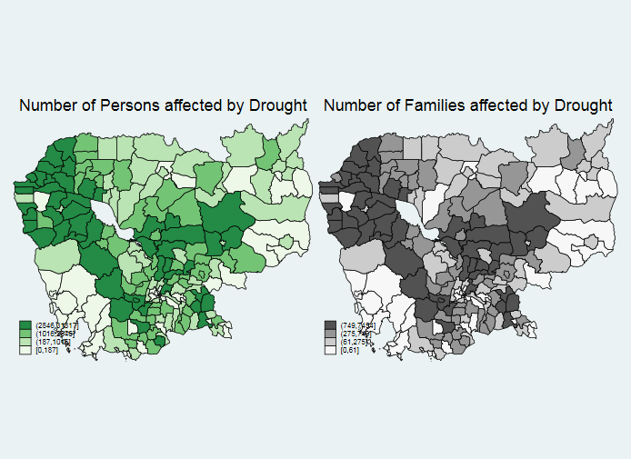

Figure 1.3: Drought Incidence Quartiles by District in Cambodia

* 1. **Asset indicators**

We employ principal component analysis to construct an asset index using the durable goods mostly used in Southeast Asia, including Cambodia. These basic goods include motorcycle, TV, mobile phone, transistor, fan/cooler, pumping, car, and refrigerator, among several others (Deutsch, 2020)[1]. Table 1.3 presents the summary statistics for durable goods.

|  |  |  |  |
| --- | --- | --- | --- |
| Table 1.3: Summary statistics for common durable goods | | | |
|  |  |  |  |
| Variable | Mean | Std. Dev. | Obs |
|  |  |  |  |
| Television | 0.800 | 0.400 | 30,851 |
| Motorcycle | 0.804 | 0.397 | 30,851 |
| Cell phone | 0.896 | 0.306 | 30,851 |
| AC/fan | 0.703 | 0.457 | 30,851 |
| Radio | 0.522 | 0.500 | 30,851 |
| PC | 0.365 | 0.481 | 30,851 |
| Refrigerator | 0.388 | 0.487 | 30,851 |
| *Notes*: This table reports the means and standard deviations of the common asset indicators in Cambodia. | | | |
|  |  |  |  |

* 1. **Other covariates**

Other covariates we control for while estimating the effect of the disaster on household financial conditions include education level, land ownership, household size, presence of a sick person in the household, road length and number of banks and microfinance institutions in the commune, and the presence of any poor card (subsidy) by a household member. We report the summary statistics for these variables in Table 1.4.

|  |  |  |  |
| --- | --- | --- | --- |
| Table 1.4: Summary statistics for other covariates. | | | |
|  |  |  |  |
| Variable | Mean | Std. Dev. | Obs |
| *Education for household head* |  |  |  |
| Primary level = 1 | 0.156 | 0.363 | 30,851 |
| Secondary level and above = 1 | 0.706 | 0.456 | 30,851 |
| Diploma/certificate and above = 1 | 0.705 | 0.456 | 30,851 |
| Degree and above = 1 | 0.705 | 0.456 | 30,851 |
| *Others* |  |  |  |
| Owns land = 1 | 0.537 | 0.499 | 30,851 |
| Household size | 4.445 | 1.762 | 30,851 |
| Any sick member = 1 | 0.511 | 0.500 | 30,851 |
| Female household head = 1 | 0.220 | 0.414 | 30,851 |
| Log of road length (commune) | 12.279 | 1.399 | 30,566 |
| Any poor card = 1 | 0.445 | 0.497 | 30,851 |
| Number of MFIs (commune) | 2.047 | 10.359 | 30,801 |
| Number of Banks (commune) | 1.256 | 11.782 | 30,801 |
| *Notes*: Any poor card is a dummy representing if at least one member of the household benefit from any type of subsidized card given for low income households. | | | |
|  |  |  |  |

1. **Methodology**

The objective of this project is to empirically estimate the impact of natural disasters on Cambodian households’ financial condition. For this purpose, we use a simple ordinary least square (OLS) or linear probability model (LPM) method. Thus, our empirical specification is

$${HHF}_{cdht}=α_{1}{DIS}_{ct}+α_{2}{FI}_{ht}+α_{3}{DIS}_{ct}×{FI}_{ht}+{X'}_{cdht}β+γ_{d}+ε_{cdht}$$

where $HHF$ represents the household financial condition, including income, expenditure, borrowing, and vulnerability. $c$, $d$, $h$, and $t$, indicate the commune, district, household, and time, respectively. $DIS$ represents a dummy if at least a single household is affected in the commune by a drought, flood, and/or storm disaster. $X$ is a vector of covariates, including education and sex of household head, household size, land ownership, whether any member of the household is sick and uses a poor card, and road length, the number of banks and microfinance institutions in the commune. While $γ$ represents the district fixed effect, $ε$ is the error term. We cluster the standard errors at the district level. $α_{1}$ and $α_{3}$ are our parameters of interest measuring the direct effect of disaster and disaster effect for those households accessing formal financial institutions.

1. **Results**

This section reports the results for the effect of natural disasters on household financial conditions. Table 3.1 presents the estimated effects of the disasters on household income. Moreover, we present the disaster impact on household expenditures in Table 3.2. Further, Table 3.3 shows the results for the effect of the disasters on borrowing and food availability. Finally, we extend our analyses to examine the impact of the disaster on additional vulnerability indicators.

|  |  |  |  |  |
| --- | --- | --- | --- | --- |
| Table 3.1: The effect of natural disaster on household income | | | | |
|  | Dependent variables | | | |
|  | Total income | Income from employment | Income from crop | Income from livestock |
| Disaster = 1 | -0.052** | -0.028 | -0.026 | 0.019 |
|  | (0.023) | (0.019) | (0.033) | (0.065) |
| Formal FIs = 1 | 0.085*** | 0.018 | -0.038 | 0.068 |
|  | (0.029) | (0.020) | (0.034) | (0.061) |
| Disaster X Formal FIs | 0.029 | 0.064** | 0.005 | -0.134 |
|  | (0.036) | (0.025) | (0.050) | (0.082) |
| Asset index | 0.159*** | 0.105*** | 0.212*** | 0.191*** |
|  | (0.008) | (0.008) | (0.011) | (0.020) |
| Secondary or above edu. | -0.062 | 0.230 | -0.281 | 0.026 |
|  | (0.334) | (0.174) | (0.325) | (0.625) |
| Diploma/certificate or above | 0.448 | -0.094 | 1.06** | 1.43** |
|  | (0.464) | (0.333) | (0.448) | (0.632) |
| Degree or above | -0.451 | -0.151 | -0.75** | -1.454*** |
|  | (0.322) | (0.284) | (0.307) | (0.080) |
| Own land | -0.086*** | -0.104*** | 0.044 | 0.477*** |
|  | (0.023) | (0.015) | (0.071) | (0.054) |
| Household size | 0.202*** | 0.140*** | 0.089*** | 0.069*** |
|  | (0.007) | (0.005) | (0.006) | (0.011) |
| Sick | -0.098*** | -0.085*** | -0.112*** | 0.036 |
|  | (0.014) | (0.011) | (0.017) | (0.039) |
| Female hh head | -0.071*** | 0.01 | -0.316*** | -0.312*** |
|  | (0.019) | (0.014) | (0.024) | (0.046) |
| Road length | 0.012 | 0.02** | -0.045*** | 0.011 |
|  | (0.010) | (0.007) | (0.014) | (0.020) |
| Any poor card | 0.106*** | 0.057*** | -0.373*** | -0.259*** |
|  | (0.030) | (0.020) | (0.043) | (0.068) |
| Number of MFIs | 0.000 | 0.00** | 0.000 | 0.001 |
|  | (0.001) | (0.000) | (0.000) | (0.001) |
| Number of banks | 0.001** | 0.001*** | -0.001*** | 0.000 |
|  | (0.000) | (0.000) | (0.000) | (0.000) |
| District fixed effect | Yes | Yes | Yes | Yes |
| Sample size | 27,034 | 19,791 | 16,271 | 10,021 |
| Adjusted R-squared | 0.238 | 0.295 | 0.215 | 0.091 |
| *Notes*: Standard errors are clustered at the district level. | | | | |

|  |  |  |  |  |  |
| --- | --- | --- | --- | --- | --- |
| Table 3.2: The effect of natural disaster on household expenditure | | | | | |
|  | Dependent variables | | | | |
|  | Total expenditure | Food exp | Non-food expenditure | Crop related expenditure | Livestock expenditure |
| Disaster = 1 | -0.027** | -0.031** | -0.018 | -0.011 | 0.039 |
|  | (0.013) | (0.013) | (0.018) | (0.030) | (0.040) |
| Formal FIs = 1 | 0.166*** | 0.051*** | 0.302*** | 0.082** | 0.079* |
|  | (0.014) | (0.012) | (0.021) | (0.034) | (0.043) |
| Disaster X Formal FIs | 0.016 | 0.021 | 0.003 | 0.003 | -0.067 |
|  | (0.017) | (0.015) | (0.026) | (0.049) | (0.053) |
| Asset index | 0.172*** | 0.092*** | 0.305*** | 0.211*** | 0.149*** |
|  | (0.005) | (0.005) | (0.006) | (0.011) | (0.017) |
| Secondary or above edu. | 0.075 | 0.030 | 0.112 | -0.051 | -0.026 |
|  | (0.073) | (0.061) | (0.120) | (0.319) | (0.311) |
| Diploma/certificate or above | -0.135 | -0.315*** | 0.194 | 0.989** | -0.614 |
|  | (0.125) | (0.121) | (0.163) | (0.430) | (0.426) |
| Degree or above | 0.042 | 0.281*** | -0.352*** | -0.927*** | 0.621** |
|  | (0.102) | (0.104) | (0.112) | (0.290) | (0.294) |
| Own land | 0.104*** | -0.044*** | 0.100*** | -0.014 | 0.481*** |
|  | (0.011) | (0.010) | (0.015) | (0.064) | (0.036) |
| Household size | 0.106*** | 0.110*** | 0.106*** | 0.078*** | 0.044*** |
|  | (0.002) | (0.002) | (0.003) | (0.006) | (0.007) |
| Sick | 0.043*** | -0.018*** | 0.157*** | -0.017 | 0.055** |
|  | (0.007) | (0.006) | (0.012) | (0.017) | (0.022) |
| Female hh head | -0.157*** | -0.141*** | -0.151*** | -0.260*** | -0.308*** |
|  | (0.008) | (0.007) | (0.012) | (0.024) | (0.028) |
| Road length | -0.007 | 0.001 | -0.013* | -0.048*** | 0.006 |
|  | (0.005) | (0.005) | (0.008) | (0.012) | (0.016) |
| Any poor card | -0.100*** | -0.059*** | -0.135*** | -0.355*** | -0.201*** |
|  | (0.013) | (0.012) | (0.017) | (0.035) | (0.040) |
| Number of MFIs | 0.001 | 0.001 | 0.001 | 0.000 | 0.001*** |
|  | (0.001) | (0.001) | (0.001) | (0.001) | (0.000) |
| Number of banks | 0.001** | 0.001** | 0.001* | 0.001*** | -0.001** |
|  | (0.000) | (0.000) | (0.000) | (0.000) | (0.000) |
| District fixed effect | Yes | Yes | Yes | Yes | Yes |
| Sample size | 30,566 | 30,563 | 30,566 | 16,286 | 16,210 |
| Adjusted R-squared | 0.542 | 0.546 | 0.469 | 0.238 | 0.107 |
| *Notes*: Standard errors are clustered at the district level. | | | | | |

|  |  |  |  |  |  |  |
| --- | --- | --- | --- | --- | --- | --- |
| Table 3.3: The effect of natural disaster on household borrowing and shortage of food | | | | | | |
|  | Dependent variables | | | | | |
|  | Total borrowing | Have debt | Cheap food | Borrow food | Reduce meal number | Reduce meal size |
| Disaster = 1 | -0.054 | 0.007 | -0.001 | -0.002 | 0.001 | 0.000 |
|  | (0.072) | (0.005) | (0.007) | (0.002) | (0.001) | (0.002) |
| Formal FIs = 1 | 0.962*** | 0.920*** | 0.012** | -0.001 | 0.002 | 0.001 |
|  | (0.065) | (0.005) | (0.006) | (0.002) | (0.002) | (0.002) |
| Disaster X Formal FIs | -0.038 | -0.021*** | -0.007 | 0.000 | 0.001 | -0.002 |
|  | (0.075) | (0.007) | (0.008) | (0.004) | (0.003) | (0.003) |
| Asset index | 0.323*** | -0.018*** | -0.031*** | -0.012*** | -0.003*** | -0.005*** |
|  | (0.016) | (0.002) | (0.003) | (0.001) | (0.001) | (0.001) |
| Secondary or above edu. | 0.070 | -0.005 | -0.015 | -0.006 | -0.008 | -0.005 |
|  | (0.377) | (0.038) | (0.014) | (0.006) | (0.004) | (0.003) |
| Diploma/certificate or above | 0.302 | -0.048 | -0.053*** | -0.016* | -0.003 | -0.009** |
|  | (0.438) | (0.048) | (0.019) | (0.009) | (0.005) | (0.005) |
| Degree or above | -0.383* | 0.045 | 0.075*** | 0.024*** | 0.011*** | 0.016*** |
|  | (0.225) | (0.029) | (0.014) | (0.007) | (0.003) | (0.003) |
| Own land | 0.015 | -0.001 | -0.013*** | -0.012*** | -0.003* | -0.004** |
|  | (0.035) | (0.003) | (0.004) | (0.003) | (0.002) | (0.002) |
| Household size | 0.033*** | 0.004*** | 0.001 | 0.000 | 0.000 | 0.001*** |
|  | (0.008) | (0.001) | (0.001) | (0.000) | (0.000) | (0.000) |
| Sick | -0.129*** | 0.031*** | 0.028*** | 0.011*** | 0.004*** | 0.006*** |
|  | (0.025) | (0.003) | (0.004) | (0.002) | (0.001) | (0.001) |
| Female hh head | -0.185*** | -0.007** | 0.013*** | 0.006*** | 0.004*** | 0.002 |
|  | (0.036) | (0.004) | (0.004) | (0.002) | (0.001) | (0.002) |
| Road length | 0.016 | 0.001 | 0.004 | 0.001 | 0.001 | 0.000 |
|  | (0.013) | (0.002) | (0.003) | (0.001) | (0.001) | (0.001) |
| Any poor card | -0.220*** | 0.022*** | 0.071*** | 0.039 | 0.012*** | 0.022 |
|  | (0.036) | (0.006) | (0.007) | (0.005) | (0.003) | (0.003) |
| Number of MFIs | 0.001 | 0.000** | 0.000* | 0.000 | 0.000 | 0.000 |
|  | (0.001) | (0.000) | (0.000) | (0.000) | (0.000) | (0.000) |
| Number of banks | 0.000 | 0.000*** | 0.000*** | 0.000*** | 0.000*** | 0.000*** |
|  | (0.001) | (0.000) | (0.000) | (0.000) | (0.000) | (0.000) |
| District fixed effect | Yes | Yes | Yes | Yes | Yes | Yes |
| Sample size | 10,221 | 30,566 | 30,566 | 30,566 | 30,566 | 30,566 |
| Adjusted R-squared | 0.376 | 0.765 | 0.103 | 0.042 | 0.019 | 0.027 |
| *Notes*: Standard errors are clustered at the district level. | | | | | | |

|  |  |  |  |  |  |
| --- | --- | --- | --- | --- | --- |
| Table 3.4: The effect of natural disaster on household vulnerability. | | | | | |
|  | Dependent variables | | | | |
|  | Ever no food | Sold HH goods | Sold prod. Assets | Spent saving | Sold house or land |
| Disaster = 1 | -0.007* | 0.001 | 0.001 | -0.002 | 0.000 |
|  | (0.004) | (0.001) | (0.001) | (0.003) | (0.001) |
| Formal FIs = 1 | -0.006* | 0.000 | 0.000 | -0.001 | -0.001 |
|  | (0.003) | (0.001) | (0.000) | (0.002) | (0.000) |
| Disaster X Formal FIs | 0.004 | 0.000 | 0.001 | 0.003 | 0.001 |
|  | (0.004) | (0.001) | (0.001) | (0.003) | (0.001) |
| Asset index | -0.018*** | -0.001** | 0.000* | -0.007*** | 0.000* |
|  | (0.002) | (0.000) | (0.000) | (0.001) | (0.000) |
| Secondary or above edu. | -0.017 | -0.001 | -0.001 | -0.005 | -0.001 |
|  | (0.029) | (0.001) | (0.001) | (0.004) | (0.001) |
| Diploma/certificate or above | 0.007 | -0.003 | -0.002 | -0.007 | -0.001 |
|  | (0.033) | (0.003) | (0.003) | (0.006) | (0.003) |
| Degree or above | 0.011 | 0.004 | 0.003 | 0.015*** | 0.003 |
|  | (0.015) | (0.003) | (0.002) | (0.004) | (0.002) |
| Own land | -0.012*** | -0.001 | -0.001* | -0.005** | 0.000 |
|  | (0.003) | (0.001) | (0.001) | (0.002) | (0.000) |
| Household size | 0.001 | 0.000 | 0.000 | 0.001 | 0.000* |
|  | (0.001) | (0.000) | (0.000) | (0.000) | (0.000) |
| Sick | 0.008*** | 0.001 | 0.000 | 0.009*** | 0.000 |
|  | (0.002) | (0.000) | (0.000) | (0.002) | (0.000) |
| Female hh head | 0.000 | 0.000 | 0.001 | 0.001 | 0.001 |
|  | (0.002) | (0.001) | (0.001) | (0.002) | (0.000) |
| Road length | -0.001 | -0.001 | 0.000 | 0.000 | -0.001 |
|  | (0.001) | (0.000) | (0.000) | (0.001) | (0.000) |
| Any poor card | 0.006 | 0.002 | 0.001 | 0.016*** | 0.001 |
|  | (0.005) | (0.001) | (0.001) | (0.004) | (0.001) |
| Number of MFIs | 0.000** | 0.000 | 0.000 | 0.000 | 0.000 |
|  | (0.000) | (0.000) | (0.000) | (0.000) | (0.000) |
| Number of banks | 0.000 | 0.000 | 0.000 | 0.000*** | 0.000 |
|  | (0.000) | (0.000) | (0.000) | (0.000) | (0.000) |
| District fixed effect | Yes | Yes | Yes | Yes | Yes |
| Sample size | 30,566 | 30,566 | 30,566 | 30,566 | 30,566 |
| Adjusted R-squared | 0.885 | 0.008 | 0.005 | 0.032 | 0.007 |
| *Notes*: Standard errors are clustered at the district level. | | | | | |

1. Joseph Deutsch, Jacques Silber, Guanghua Wan, Mengxue Zhao. 2020. Asset indexes and the measurement of poverty, inequality, and welfare in Southeast Asia, Journal of Asian Economics, 70, 101220.